Synopsis

Machine Learning-Based Fraud Detection System for Financial Transactions

Problem Id: 12

Astha Negi
2028677
Section K

Kartik Chaudhary
2028442
Section K

Aadi Sharma
2028372
Section K

- Problem Description:

With the rapid growth of online transactions and digital payment systems, the risk of financial fraud has also increased significantly. Fraudulent activities not only cause monetary loss but also reduce user trust in digital platforms. Detecting such fraud is challenging because fraudulent transactions are very rare compared to normal ones, and their patterns keep changing over time.
This project aims to develop an efficient machine learning-based classification system to identify fraudulent transactions using transaction-level financial data.
The dataset is preprocessed by handling missing values, encoding categorical variables, and scaling numerical features. Since the dataset is highly imbalanced, appropriate techniques are applied to ensure accurate fraud detection.
Different classification algorithms such as Logistic Regression, K-Nearest Neighbors (KNN), and Support Vector Machine (SVM) are implemented and compared. The performance of these models is evaluated using metrics like accuracy, precision, recall, and ROC-AUC to select the most effective model.
This system can help financial institutions improve fraud detection and enhance the security of digital transactions.
- Steps of Implementation:

- Data Collection
The PaySim dataset from Kaggle is used, which contains transaction-level financial data.
- Data Preprocessing
Missing values are handled, unnecessary columns are removed, and categorical data is encoded into numerical form.
- Feature Engineering
New features such as balance differences are created to improve model performance.
- Data Splitting
The dataset is divided into training and testing sets using stratified sampling.
- Data Scaling
StandardScaler is applied to normalize numerical features.
- Handling Imbalanced Data
SMOTE technique is used to balance fraud and non-fraud transactions.
- Model Training
Logistic Regression, KNN, and SVM models are trained on the dataset.
- Model Evaluation
Models are evaluated using accuracy, precision, recall, F1-score, and ROC-AUC.
- Model Comparison
Performance of all models is compared to select the best one.
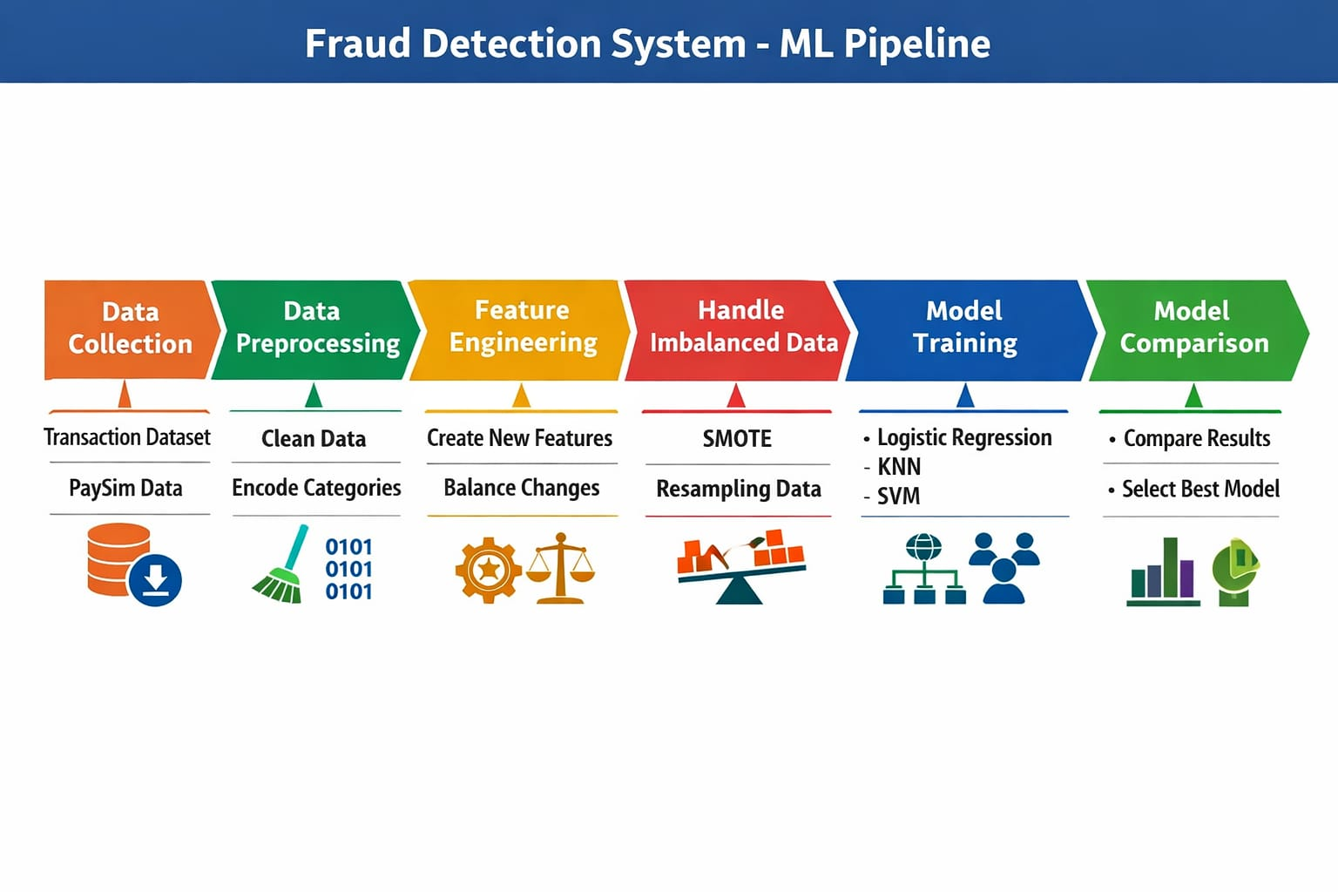
Fig 1. Each phase of ML pipeline used
- Expected Modules/ Libraries to be used :
- Pandas → Data manipulation and analysis
- NumPy → Numerical computations
- Matplotlib / Seaborn → Data visualization
- Scikit-learn → ML models and preprocessing tools
- Imbalanced-learn (SMOTE) → Handling imbalanced datasets
- Pickle → Saving trained model

- Expected Evaluation metrics and Plots to be used:
- Accuracy → Measures overall correctness of the model by calculating the proportion of correctly classified transactions
- Precision → Used to measure how many of the transactions predicted as fraud are actually fraudulent. It helps in reducing false positives.
- Recall → Used to measure how many actual fraudulent transactions are correctly identified. It is important in fraud detection to avoid missing fraud cases.
- F1-score → Used to provide a balance between precision and recall, especially for imbalanced datasets.
- Confusion Matrix → Used to show the number of correct and incorrect predictions, including true positives, true negatives, false positives, and false negatives.
- ROC Curve & AUC Score → ROC Curve is used as the main evaluation plot in this project. It visualizes the performance of the classification models by plotting the true positive rate against the false positive rate at different threshold values.
AUC (Area Under the Curve) is used along with the ROC curve to measure the overall performance of the models.
- Required topics from the subject:
1. Machine Learning
Machine learning involves training models to learn patterns from data. In this project, supervised learning is used for classification.
2. Data Preprocessing
Includes cleaning data, handling missing values, encoding categorical variables, and scaling features to improve model performance.
3. Classification Techniques
Logistic Regression, KNN, and SVM are used to classify transactions as fraud or non-fraud.
4. Model Evaluation
Performance is measured using accuracy, precision, recall, F1-score, and ROC curves.

- Platform Required:
- Jupyter Notebook
- Books and Link Sources:
- Kaggle Dataset:
https://www.kaggle.com/datasets/ealaxi/paysim1⁠
- Scikit-learn Documentation
https://scikit-learn.org⁠
- ChatGPT (for conceptual understanding and guidance):
https://chat.openai.com⁠
- https://matplotlib.org/

